Client Pictures using MS Paint
A client picture must conform to 3 rules.
- The file cannot be larger than 20kb
- The file must be in either .jpg or .png format
- The picture cannot be larger than 125x125 pixels

- The best original picture is a “headshot” style picture (like for a passport). You can crop from a snapshot style but the quality will not be as high. The size and format of the starting picture does not matter.
Best original is like this. | Though you can select a starting picture from a snapshot.
 | 

- Save the picture to a spot on your computer (where you can find it)
- Open Microsoft Paint.
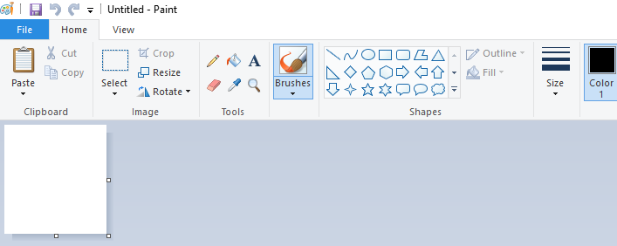
- Click the File tab and then click Open
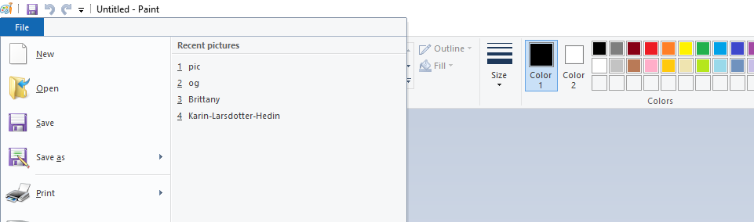
- Find the picture you saved (in Step 2) Click it and Open it
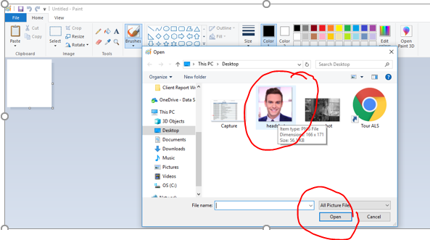

- This is what you will see in Paint. Now Click Select
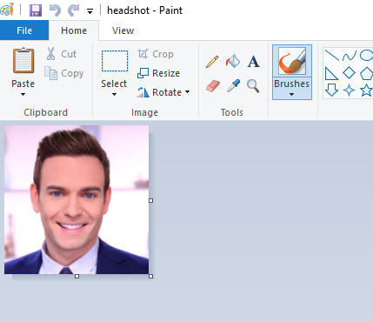
- Put your mouse in the upper left corner, and while holding down the left side (index finger) drag it down to the bottom right.
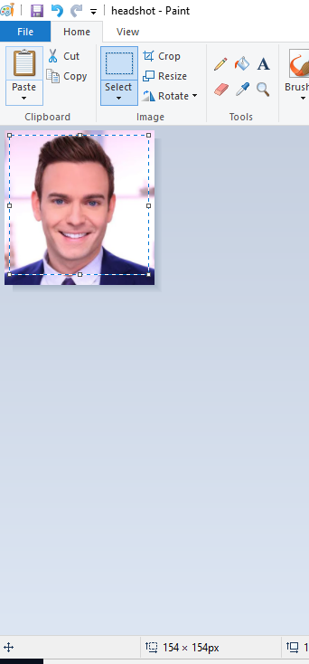

This part is tricky… watch the numbers at the bottom and move the mouse until they are as close to the same as possible. The same means you have a square picture. Then TAKE your hand off the mouse.

- Next click Crop, then click Resize.

- This popup appears. Change the By: selection to x Pixels and change the larger of the 2 numbers (either Horizontal, or Vertical) to 125. (If they are not the same.) Then click OK.
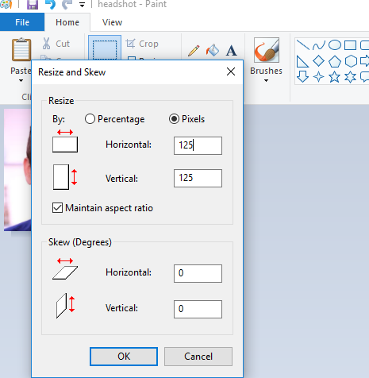
- Now click Save as / JPEG picture.
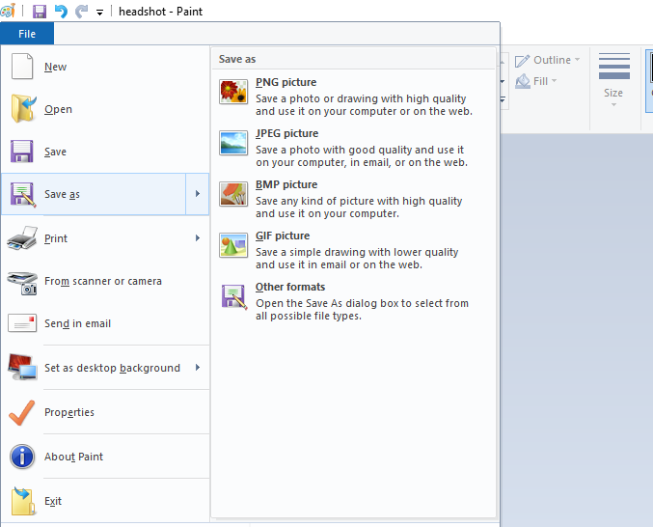

- Save the, 125x125 pixel picture as a .jpg where you can find it.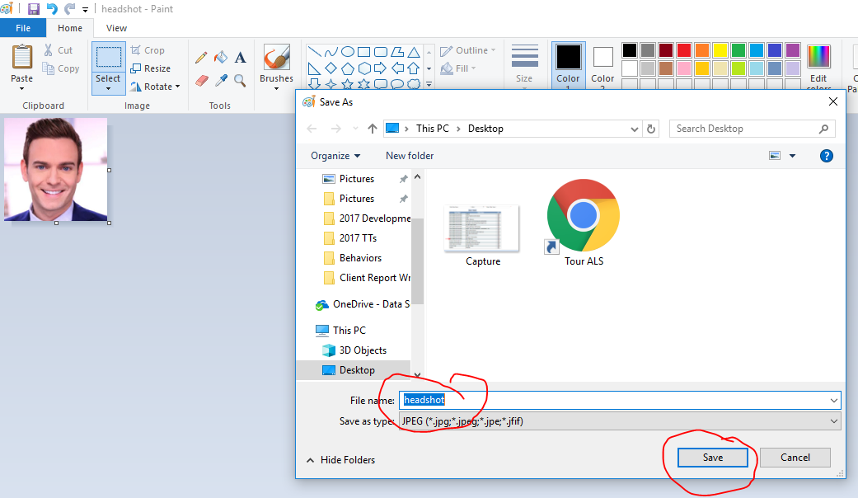
- Here is my folder called desktop. Item 1 is the original headshot and Item 2 is the resized headshot that I will save as a client picture.
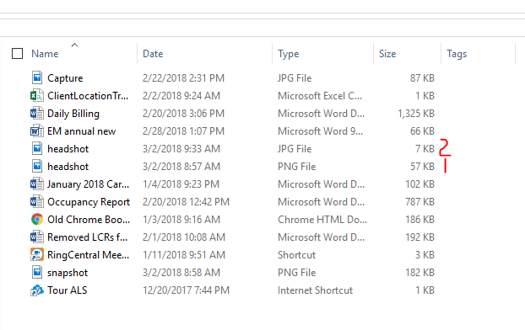

Save to Client Information and Program
- Click Choose File from the Client’s Admissions page.
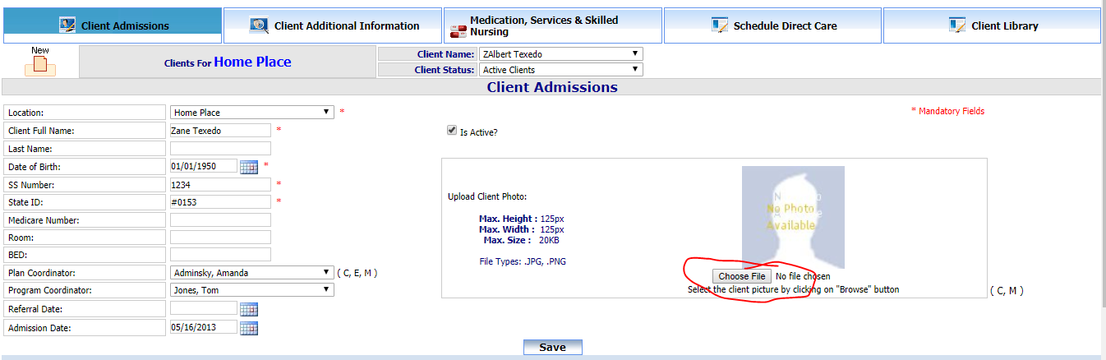
- Select the resized .JPG file (see step 12) and then click Open
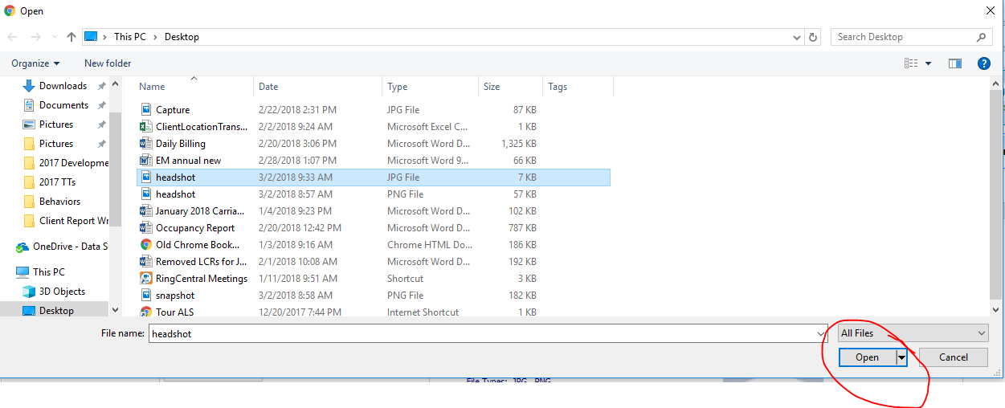
- Then click Save
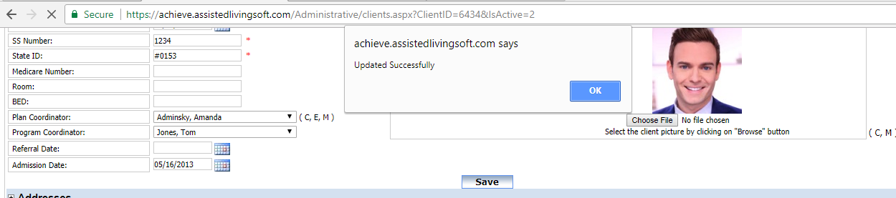
If the picture does not save it is due to 1 of these 3 reasons.
The File is larger than 25kb.
The file is not a .jpg or png.
The picture is larger than 125x125 pixels.

